Transition Pathway Services Demonstration Grant
Massachusetts Rehabilitation Commission
Introduction
Massachusetts Rehabilitation Commission was awarded a 5 year, 5 million dollar federal grant from the Rehabilitation Services Administration in the Fall of 2016.
The Transition Pathway Services (TPS) Demonstration Grant develops a coordinated set of services provided by community partners including vocational rehabilitation, career centers, independent living centers, pre-employment transition vendors and local educational authorities to increase employment and/or post-secondary education opportunity for students with disabilities.
The ten services components in the TPS model include:
- 2 Work Based Learning Experiences
- Vocational Counseling
- Workplace Readiness Training
- Benefits Counseling
- Assistive Technology
- Transportation Coordination
- Vocational Assessments
- Peer Mentoring
- Customized Job Placement
- Family Support Transition Planning.

Project Goals
Inputs | Outputs | Outcomes-Impact
- MRC  - Pre-ETS vendors  - MRC cross-agency partnerships (IDD, MH, etc.)  - MA Department of Education  - MA DOL & Workforce  - ICI  - MA ILCs  - Community Partners  - Project Advisory Group  - Student Advisory Group  - Business Advisory Group | TPS Intervention Implemented to Include components:  - 2 WBL Exp.  - Workplace Readiness  - Assistive Technology  - Career Discovery Teams  - Voc counseling  - Benefits counseling  - Transportation coordination  - Peer mentoring  - Family support transition planning  Formalized Partnerships and Contacts with partners an Vendors  Business outreach plan  651 Students in Roxbury, Lawrence, and Springfield, MA area who are receive TPS intervention.  651 Career Discovery Teams coordinating services  MA businesses providing work based learning experiences | SHORT TERM  - Students improve knowledge and skills in academic and careers planning  - Students successfully complete 2 work experiences (one paid)  - Students complete high school  - Students are satisfied with TPS services  - Employers are satisfied with work experiences  Systems-level:  - Key stakeholder partners engage in coordinated team efforts  LONG TERM  - Students are either in a competitive job and/or pursuing post-sec education  - Increase by 10% the number of business engaged with VR and providing WBL experiences to students with disabilities.  Systems-level:  - Improved coordination of transition services  - Evidence on TPS model impact disseminated
Theory of Change
Transition Pathway Services believes if students have access to a coordinated Career Discovery Team of transition services that this can improve academic and career planning along with skill development that will lead to improvements in employment outcomes and postsecondary educational opportunities. The field of transition can be fragmented and redundant, through TPS efforts, students will have a more seamless transition planning process preparing them for life after high school.
Career Discovery Team Strategy
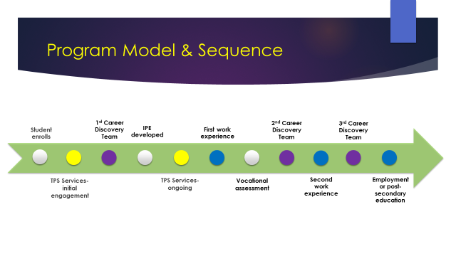

Next Steps
- Strengthen relationships with employers to support work readiness training and opportunities
- Explore how the Career Discovery Team reduces barriers to services and information
- Document promising practices around engaging students in vocational rehabilitation and work based learning
- Develop trainings, guidance, and tools for all MRC Counselors working with students
- Strategize about sustainability

