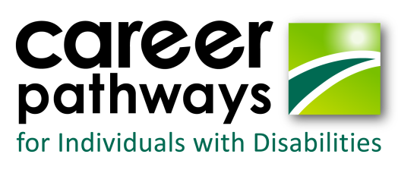

2017 Dream It. Do it. Academies

Date | Camp | Location | Number of Students
June 12-16 | 3-D Imaging | Lake County Advanced Learning Center | 12-14
June 26-30 | Welding | Lake County Advanced Learning Center | 12
June 26-30 | Robotics/Cyber* | Richmond- DBVI campus | 26
July 2-7 | Production/Water filtration* | Wilson Workforce and Rehabilitation Center | 14-16
July 10-14 | Gaming | SSVCC Daniel Campus | 12
July 10-14 | CNC-Machining* | Valley Career and Technical Center | 10-14
Sept 15-17  (weekend) | 3 D Printing  Adult Academy | Dabney S Lancaster Community College | 12
*Denotes a residential academy with dormitory housing available for attendees
Assistive technology provided at all CPID academies

Need more information? Email:
Tish Harris, DBVI: Tish.Harris@DBVI.Virginia.Gov
Kate Kaegi, DARS: Kate.Kaegi@DARS.Virginia.Gov
For a listing of all Dream it. Do it. camps: https://www.dreamitdoitvirginia.com/

Virginia’s Career Pathways for Individuals with Disabilities (CPID) grant is a federally-funded grant project (CFDA #84.235N) through the Department of Education.

