Assistive Technology for Supporting People with Mental Health Conditions in the Workplace

Mark Harniss, Maria Kelley, and Rick Kugler

The prevalence of adults in the U.S. population with any mental illness is approximately 18%, while the prevalence of adults with serious mental illness (i.e., serious functional impairment) is 4% (NSUDH, 2015). This means that are a significant number of Americans who are likely to encounter barriers and challenges involving the integration into community life, particularly in terms of social inclusion and financial well-being.

Mental Health and Employment
The unemployment rate for people receiving public mental health services is approximately 80% and employment rates have declined from 23% in 2003 to 17.8% in 2012. Approximately 60% of the 7.1. million people receiving public mental health services want to work, but less than 2% receive supported employment opportunities. Work disincentives in public benefits encourage unemployment because an individual may return to work, lose SSDI and SSI, but not receive mental health services as part of an employer sponsored plan. There are several factors that contribute to the limited workforce participation that is common to people with significant mental illness.

Education
Mental illness is related to early termination of schooling at all levels, with the highest proportion of terminations attributable to mental illness at high school (10.2%). Substance use and disruptive disorders are more related to early school leaving than mood and anxiety disorders. Socio-economic status is a significant mediating factor between mental disorders and educational attainment which often contributes to limitations in job opportunities and overall career attainment.

Criminal Justice Involvement
Estimates suggest there are ten times more seriously mentally ill persons in jails and prisons than in hospitals: 356,268 in jails and 35,000 in state psychiatric hospitals. In 44 of 50 states, a prison or jail in that state holds more individuals with serious mental illness than the largest remaining state psychiatric hospital. Approximately 40% of individuals with serious mental illness have been in jail or prison at some time in their lives. Some argue that we moved from de-institutionalization in the 1960s to trans-institutionalization in prisons and jails currently because mental health programs are so poorly funded.

Cognitive barriers
People commonly make a division between cognitive disability (how we think) and mental illness (how we act or behave or believe); however, they are related. Some researchers hypothesize that cognitive disabilities support or maintain some of the behaviors seen in people with mental illness. For example, some people with schizophrenia have poor executive functioning, which has been linked to insight of illness and may underpin poor medication compliance, self-injurious behavior, and assaultive behaviors. In addition, some of these same people have poor working memory, which may underpin formal thought disorder and derailment (loose association, rambling, rapid switching of topics).

Mental Health and Assistive Technology
Lots of research and practical knowledge has been developed about assistive technology for people with cognitive disabilities. Unfortunately, almost none of it focuses on people with mental illness and the co-occurring cognitive disabilities that accompany many forms of mental illness. Because of this, we should apply what we know about AT for cognition to the needs of people with mental illness, but with one important caveat. AT for cognition will likely be most effective when other symptoms of mental illness are under stable control either through medication or appropriate counseling.

One thing we do know is that people with mental health conditions use technology. In a 2013 study, a large group of individuals (N=1,568) with schizophrenia (58%); bipolar (22%); major depressive (14%); and substance use disorder (28%) were surveyed. Of these individuals 72% owned a mobile device (12% less than general population). Device ownership was more common among those with mood disorders (86%) than those with schizophrenia (63%). Eighty-one percent of those who owned a device and 62% of those who did not expressed interest in receiving mental health services via mobile technology in the future. Cost was the most common barrier to ownership.

In another survey of people with schizophrenia (N=457; 2016), 90% of the individuals surveyed owned more than one digital device such as a personal computer, tablet or smartphone and 54% had access to smartphones compared to 64% of all Americans. Many of the respondents use their devices to cope with mental illness.
- 42% by blocking or managing auditory hallucinations with music or audio files
- 38% for health information on the Internet
- 37% for calendar reminders
- 32% for transportation and map needs
- 28% for medication management
- 26% for supporting others
- 26% for developing relationships with other persons with schizophrenia
- 25% for monitoring symptoms
- 24% for identifying coping strategies.

How Can Assistive Technology Help?
Assistive technology may be helpful in several ways, including cognitive support, calming and reducing arousal, self-management, and passive symptom tracking. These technologies are described below and examples are listed in Appendix A.

Cognitive support
A wide range of technologies provide cognitive support. These devices and systems are not specifically designed for individuals with mental health condition, but may be beneficial. They include reminders, schedulers, and task management applications.

Calming/reducing arousal
Technology to help an individual calm themselves and reduce arousal can be useful for individuals with mental health conditions. They include technology that helps to soothe and comfort, and increase mindfulness (for reduction of anxiety) as well technology that helps to distract or disrupt an individual (to reduce agitation).

Self-management
A number of technology based systems (e.g., apps, software) for self-management are available. These include mood and behavior trackers and screeners, safety and monitoring trackers (e.g., risk behaviors), and sleep and diet trackers.

Passive symptom tracking
A newer class of technology collects data about an individual’s physiological state throughout the day. These devices can measure such things as respiration rate, pulse, galvanic skin response, and other correlates of stress. Using this information, individuals can look for functional relationships between events, locations, and activities that increase or reduce stress responses.

Choosing Assistive Technology
Because there are many AT options, a thorough process helps to identify the most appropriate choices. Given that up to 50% of all AT is abandoned, it is important to ensure that an AT evaluation is conducted that investigates:
- A user’s technology preferences,
- The tasks to be accomplished,
- A range of options (no-tech, light-tech, high-tech),
- The environmental supports & constraints.

A user should never purchase a device without trying it out. The AT Act Programs in each State are a good place to find technology that can be demonstrated and loaned before purchase (https://www.ataporg.org/).

Implementing Assistive Technology Solutions
Once technology is purchased the user may still need ongoing services (evaluation, training, follow up, repairs), and possibly reevaluation since his or her functional capabilities can change over time. Without these services, they may fail to use the AT to its best advantage (e.g., not use all relevant features) or abandon the AT completely. Additional considerations include helping the worker with a mental health condition manage the technology and properly integrate it into their workplace routine. Common issues around work-related use of AT, particularly Smartphone technology, include disclosure and work appropriate usage.

Disclosure

The ADA protects people with mental health disabilities as it does those with other disabilities in terms of the right to a reasonable accommodation. A common difference is that the need for an accommodation can be less apparent for people with mental health condition, therefore they may have to be more proactive in disclosing their disability and presenting accommodation strategies to their employer. In some respects, workplace disclosure for people with a mental health diagnosis may represent a combination of risks and benefits. Disclosure can result in a much-needed accommodation or may result in stigma and discrimination, or sometimes can result in both.

It is important for workers who are going to use smart phone related assistive technology as an accommodation to be aware of the workplace culture. In some instances, periodic use of a cell phone at work may be common practice so disclosure may not be an issue; in other workplaces cell use may be prohibited. This means the employee with a disability may need carefully plan his or her approach in requesting an accommodation from the employer. They should decide how much detail they want to disclose about their disability as well as develop some key talking points to advocate how using that technology will help them be a more productive and effective employee. Planning ahead can help people give the necessary information to get the accommodations they need while avoiding sharing details they may later regret.

Appropriate use of Technology

Another key issue about using assistive technology is to help the employee use it effectively so that it helps them to be a productive employee. It would be hard to deny that cell phone can distraction for any user, including those with disabilities. While anyone can get distracted, individuals with certain mental health may be have more susceptibility to distraction.

A person can start out with good intentions to use their smart phone in the workplace to help them mitigate a symptom or manage some feature of their work duties. While there is certainly a benefit of receiving a prompt from the phone to remind one to perform a certain task for example, there are myriad of buzzes, beeps, vibrations and other notifications they people receive that can take someone’s mind off the job. If a person needs to use their phone consistently as accommodation, they will need to think about creating “boundaries.” They may benefit from support in identifying the technology features that support them on the job and avoiding the features that may distract them like responding to a friend’s text, looking a news alerts and updating their social media page. Fortunately, most smart phones offer flexibility in determining which notifications can be prioritized so with some planning, potential distractions can be reduced.

Pros and Cons of AT for Mental Health
Technology supports for people with mental health conditions have pros and cons. On the positive side, they may:
- Be more convenient than alternative treatment approaches because individuals can use them at times and locations of their choice,
- Allow for more anonymity for individuals who do not want to seek face to face therapy,
- Provide an introduction to care for individuals who have avoided it in the past,
- Be available for lower cost than traditional care, and
- Allow for service to be provided to more people, for example in remote areas or during crises.
In addition, technology may be used to support other treatment approaches such as traditional therapy.

One the negative side, there is a lack of scientific evidence that AT approaches work and that they are as effective as traditional methods, and there are no industry-wide standards to help consumers know if an app or other mobile technology is proven effective. It is also unclear whether apps work for all people and for all mental health conditions. Many of these technologies collect very sensitive personal information so users need to understand the privacy risks they are taking. In addition, the question of who will or should regulate mental health technology and the data it generates needs to be answered.

Appendix A: Examples of Assistive Technologies for Mental Health
*Note: These examples are not intended as product endorsements, but are provided to show the types of technologies available on the market.

AT for Memory Loss

Medication Aids
Pillpack  Medications organized in individual packs that can be ordered online or by phone and allow for insurance billing: https://www.pillpack.com/. | 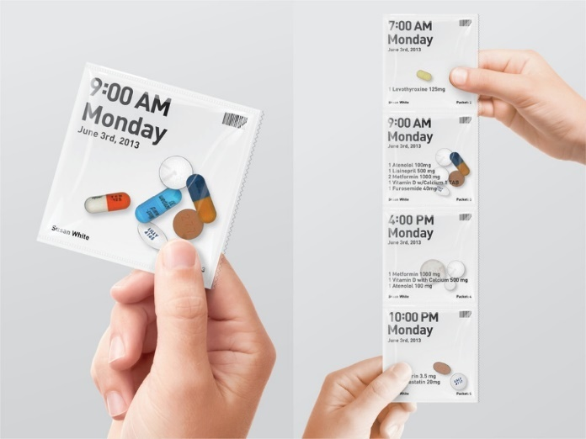
HERO Pill Dispenser  Automated pill dispenser that can send notifications to support person if medications are taken. Automates reminders of medication times and dispenses pills on specific schedules: https://herohealth.com/. | 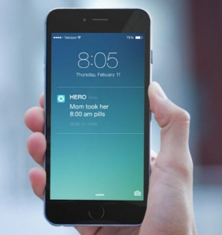
MyMed Schedule (free iOS, Android)  - Keep track of medication  - Refill Reminders  - Healthcare Provider Profiles  - Insurance Information  - Allergies | 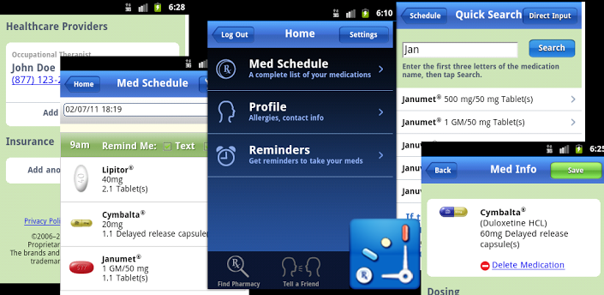

Trackers/Locators
Bluetooth Beacons Location tags that help locate lost items  - Stick n Find  - Tile  - Pixie | 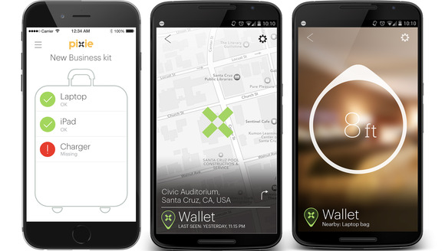  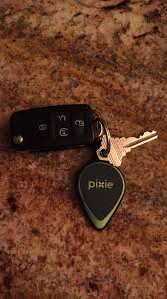

Organization
Google Calendar
- Allows user to schedule one time or recurring appointments
- Reminders can be created
- Can be synched to smartphone, computer and tablets allowing for user to enter and access information from various locations
- Shared calendaring can be set up if additional support is needed

Task Management
30/30 (free, iOS, Android, Windows)  - Set up tasks and time needed to complete  - App will tell you when to move onto next task | 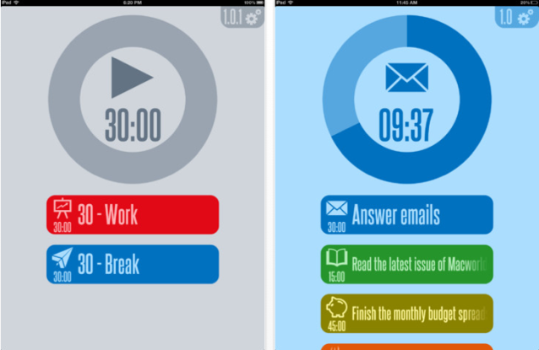
Evernote (free, iOS, Android, Windows)  - Allows you to store text, photos, and audio notes on your device of choice. Create "notebooks" and categorize notes for meetings and to-do lists. Notes are tagged with geo-location for mapping or search. Keep all info in one place | 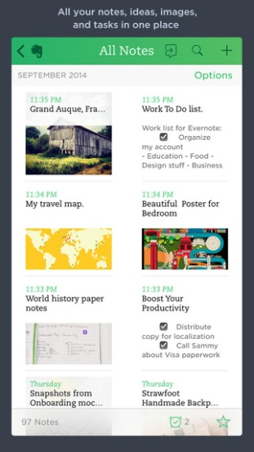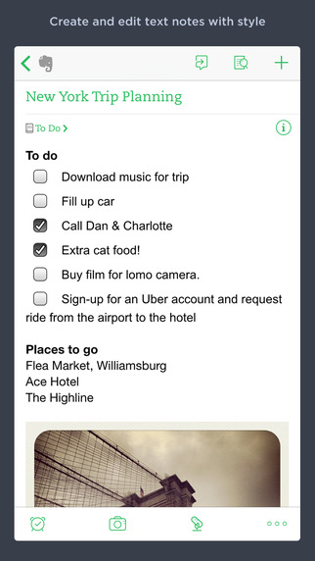

Reminders
Ablelink Technologies Endeavor 3 ($99, iOS)  Scheduling and to do list app | 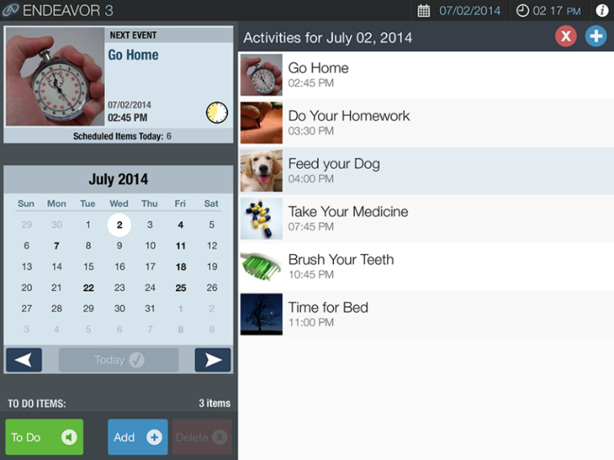

Visual Schedule/Modeling Apps
Pictello  - Visual story creator to develop skills  - Easy to customize  - Multimedia can be integrated | 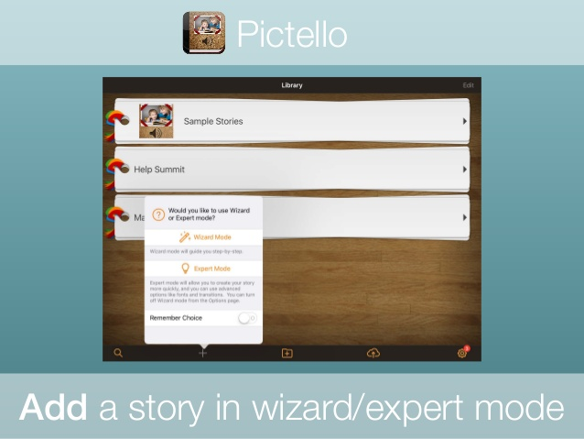
Visual Schedule Planner  - Designed to give an individual an audio/visual representation of the “events in their day “  - Able to view events daily, weekly or via a monthly calendar.  - Custom images  - Custom sound  - Activity schedules  - Video Modeling  - Timer  - Checklist  - Reminders  - Notes | 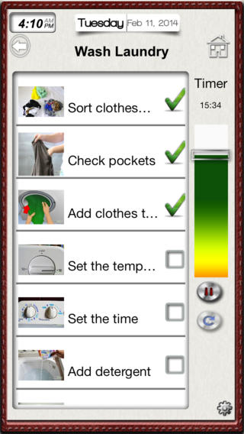  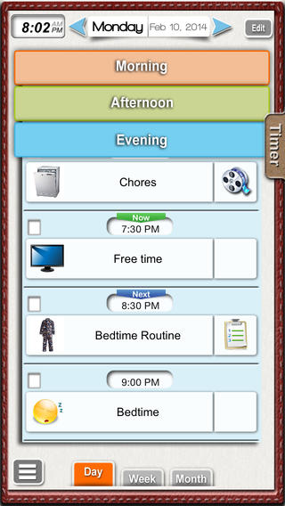
Visual Impact 3  - Provides step by step multimedia instructions for various tasks  - Custom tasks can be created  - $150, iPad  - http://www.ablelinktech.com | 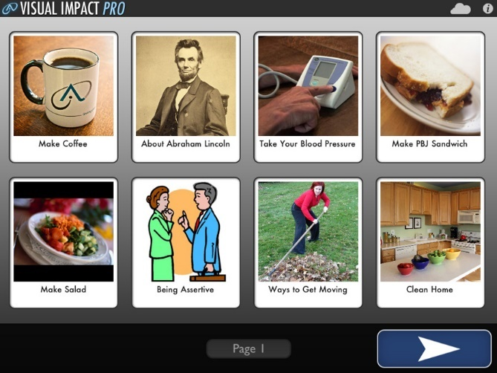

Work Autonomy App  - Full featured app designed to provide support in work environments  - 3 areas of support  - Communication  - Tracking tasks  - Work schedules  - Each section allows for the capture and editing of content using video, photo, text and/or voice to meet the communication preferences and processing needs of the user. | 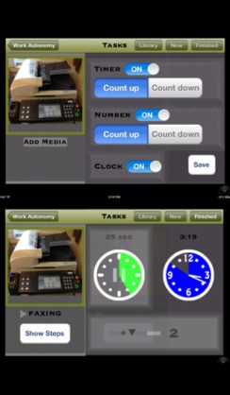  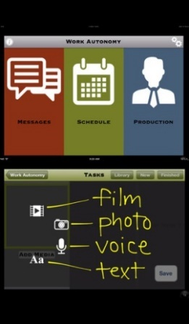
ShowMeQR  - iOS and Android  - Manager app $2.99  - Scanner app $0.99  - Assist with the understanding and completion of tasks at home, school, or work  - Creates and prints proprietary codes that can be placed on objects  - After scanning the code, instructional videos or written instructions are presented  - Immediate live video or telephone support available | 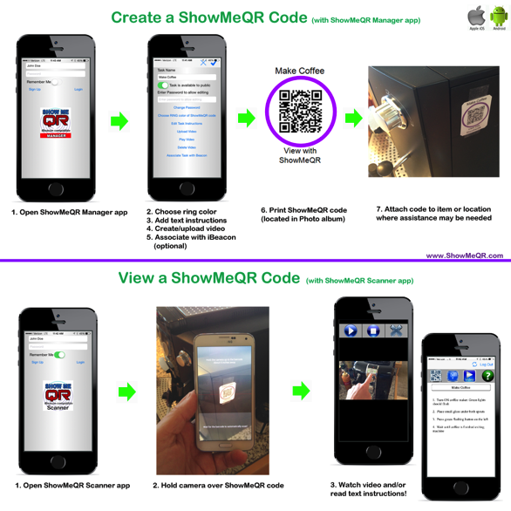
Echo by Amazon  - Echo is always ready, connected, and fast  - Add items to “to do” list  - Stay on time and organized with voice-controlled alarms, timers, shopping, and to-do lists  - Get information from Wikipedia, definitions, answers to common questions, etc.  - Echo App allows you to manage alarms, lists, etc. | 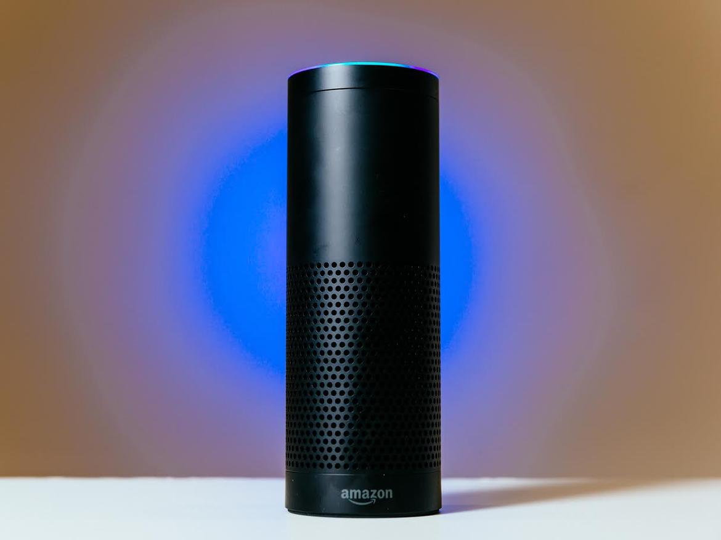

Calming/Reducing Arousal

T. Jacket by T. Ware  - Wearable technology  - Provides deep touch pressure to calm/soothe individual who is anxious or stressed  - Pressure controlled via smartphone iOS or Android  - Child/Adult sizes; $599 | 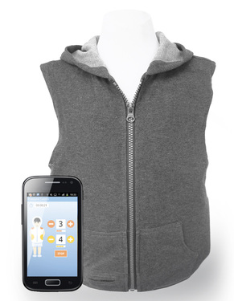
b-Calm  - Products for adult and children ($109 -$205)  - Preloaded audio sedation tracks  - Acoustic masking signals work to make typically distracting noises unapparent to the user  - Audio recordings to help with relaxation and focus | 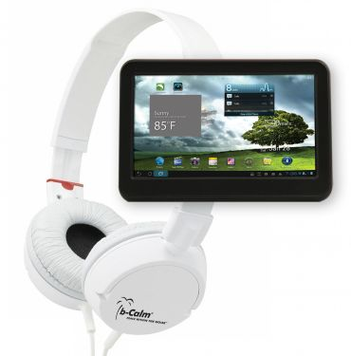

Modifications to the Work Environment
- Provide private office or work area with limited distractions/low traffic area  - Noise reducing headsets/ noise reduction ear muffs  - Can decrease help to reduce stress and improve concentration  - Can also reduce ambient noise at night and help with sleep | 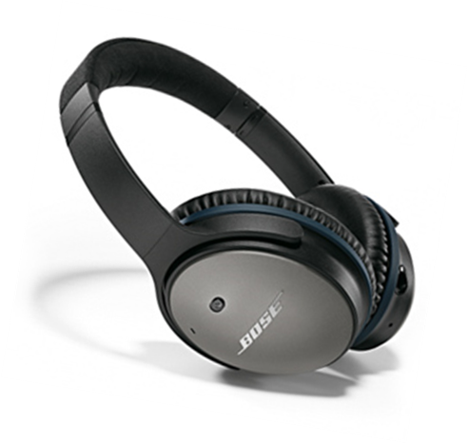
- Provide natural light or therapy lamps  - Simulate outdoor lighting  - Many options…make sure designed for SAD  - Light box should emit reduced UV light  - Brightness will affect hours of use; consult healthcare provider for hours of use  - Recommended distance 2 feet from user | 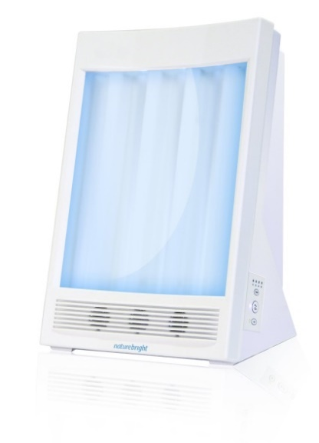

Self-Management

Apps for Mood/Emotion Management
T2 Mood Tracker (free iOS, Android)
- Allows users to monitor moods on pre-loaded scales
MindShift (free iOS, Android)
- Tools for relaxation; develops new thinking; suggests healthy activities
Breathe2Relax (free iOS, Android)
- Uses guided breathing exercises to reduce anxiety

Self-Help for Anxiety Management (SAM) (free iOS, Android)  - Tell the app how you’re feeling, how anxious you are, or how worried you are  - App’s self-help features walk you through some calming or relaxation practices. | 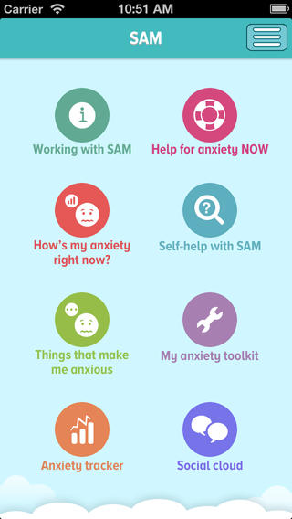  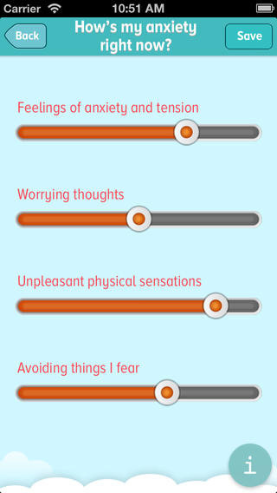
DBSA Wellness Tracker  Depression and Bipolar Support Alliance  - Online - iOS App - Android App  - www.DBSAlliance.org/Tracker  - Provides key health trends for mood disorder  - Overall Mood – (depressed to manic)  - Well-Being – (cheerful, calm, active, rested)  - Mood Disorder Symptoms – (rate and comment)  - Lifestyle (including sleep, exercise, etc.)  - Medication and Side Effects  - Physical Health | 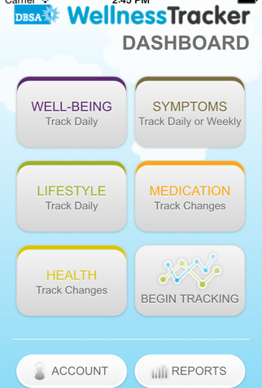
PTSD Coach  - Reliable information on PTSD and treatments that work  - Tools for screening and tracking your symptoms  - Convenient, easy-to-use tools to help you handle stress symptoms  - Direct links to support and help  - Always with you when you need it | 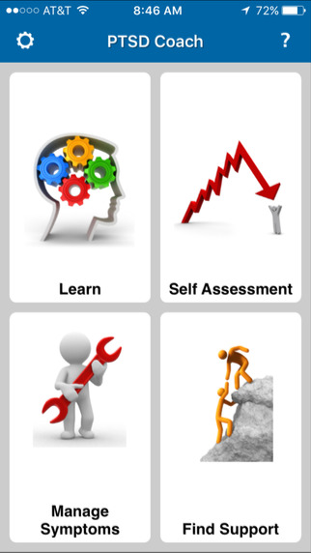
Pacifica  - An app for stress, anxiety, and worry based on Cognitive Behavioral Therapy, relaxation, and wellness.  - Track your mood  - Guided relaxation techniques  - Thought diary  - Health tracking (exercise, sleep, caffeine)  - Set Daily Goals  - Review mood history | 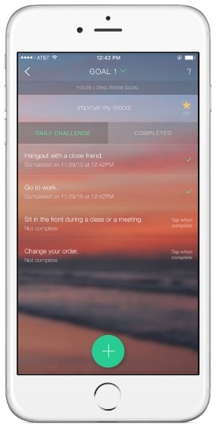

Apps for Sleep Management
- Sleep Time-Alarm Clock (free, iOS, Android)  - Sleep Cycle ($1, iOS, Android)  - Sleepbot (free, iOS, Android) | 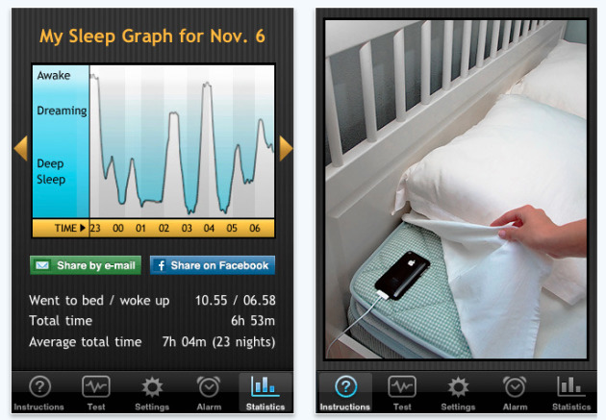

Apps for Nutrition & Fitness
MyFitnessPal  - Track food intake  - Track exercise  - Participate in community | 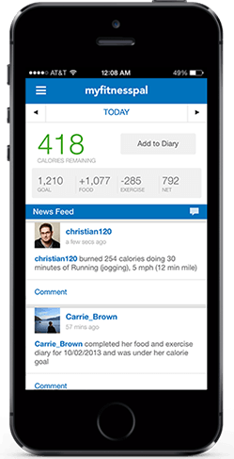

Passive Symptom Tracking
Embrace Watch  - Stress management  - Monitors physiological stress  - Sleep Management  - Activity Tracker | 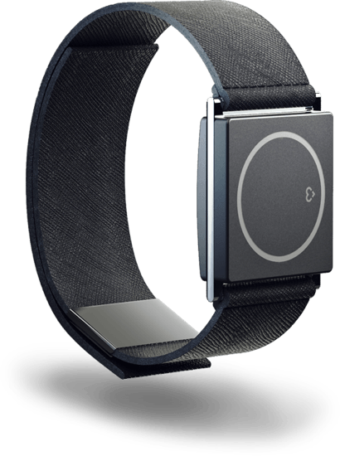
Spire (Mindfulness/Relaxation)  - “Fitbit for the mind”  - Measures breathing patterns and tracks steps.  - Breathing visualizations.  - Guided breathing meditations. | 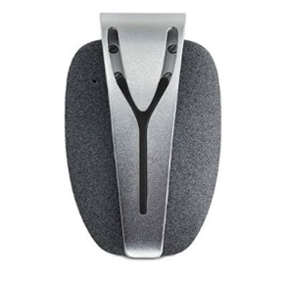
Withings Aura (Sleep)  - Passively tracks sleep patterns (heart rate, motion, respiration) and sleep environment (light, noise, temperature).  - App visualizes sleep patterns.  - System identifies best time to wake you up. | 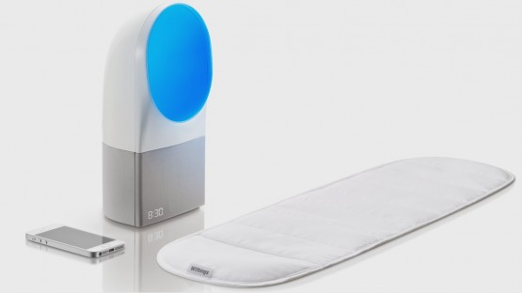

References
Ben-Zeev, D., Davis, K. E., Kaiser, S., Krzsos, I., & Drake, R. E. (2013). Mobile Technologies Among People with Serious Mental Illness: Opportunities for Future Services. Administration and Policy in Mental Health, 40(4), 340–343.
Breslau, et al. (2008). Mental disorders and subsequent educational attainment in a US national sample. J Psychiatr Res; 42(9): 708–716.
Esch, et al. (2014). The downward spiral of mental disorders and educational attainment: a systematic review on early school leaving. BMC Psychiatry, 14:237
The National Alliance on Mental Illness (NAMI). (2016). Schizophrenia: Digital Technology Defies Stigma, Supports Recovery. Downloaded on 2/11/17 from https://www.nami.org/Press-Media/Press-Releases/2016/Schizophrenia-Digital-Technology-Defies-Stigma,-S#sthash.dlEiuqim.eJjzCryK.dpuf.
Torrey, et al. (2014). The Treatment of Persons with Mental Illness in Prisons and Jails: A State Survey. Downloaded on 2/11/7 from http://www.treatmentadvocacycenter.org/storage/documents/treatment-behind-bars/treatment-behind-bars.pdf.

